RaceDay – Part 1: System Planning and Database

Module: PROG6212 – Programming 2B
Assessment: Portfolio of Evidence – Part 1 (System Planning and Database)

This document contains Section A (Entity Relationship Diagram) and Section B (API Endpoint Plan) of the RaceDay system planning submission. Section C (the SQL database script) is submitted separately as `RaceDayDatabase.sql` in this same `/docs` folder.

---

Section A – Entity Relationship Diagram (ERD)

The RaceDay data model consists of six entities: **Users**, **EventTypes**, **Events**, **Categories**, **Enrolments**, and **Results**. Organisers and Participants are both stored in a single `Users` table, distinguished by a `Role` column, since both share the same authentication and profile structure. `EventTypes` is a lookup table for Run, Walk, and Cycle, keeping event classification consistent rather than relying on free text. `Enrolments` acts as the associative entity linking a Participant, an Event, and a Category, and `Results` extends an Enrolment with a finish time and position once the event concludes.

Relationship Summary

| Relationship | Cardinality | Description |
|---|---|---|
| Users → Events | 1 to many | One Organiser creates many Events |
| EventTypes → Events | 1 to many | One EventType (Run/Walk/Cycle) applies to many Events |
| Events → Categories | 1 to many | One Event has many Categories |
| Users → Enrolments | 1 to many | One Participant has many Enrolments |
| Events → Enrolments | 1 to many | One Event receives many Enrolments |
| Categories → Enrolments | 1 to many | One Category is selected in many Enrolments |
| Enrolments → Results | 1 to zero-or-one | One Enrolment produces at most one Result |

This ERD matches the structure implemented in `RaceDayDatabase.sql` exactly, including all primary keys, foreign keys, and constraints.

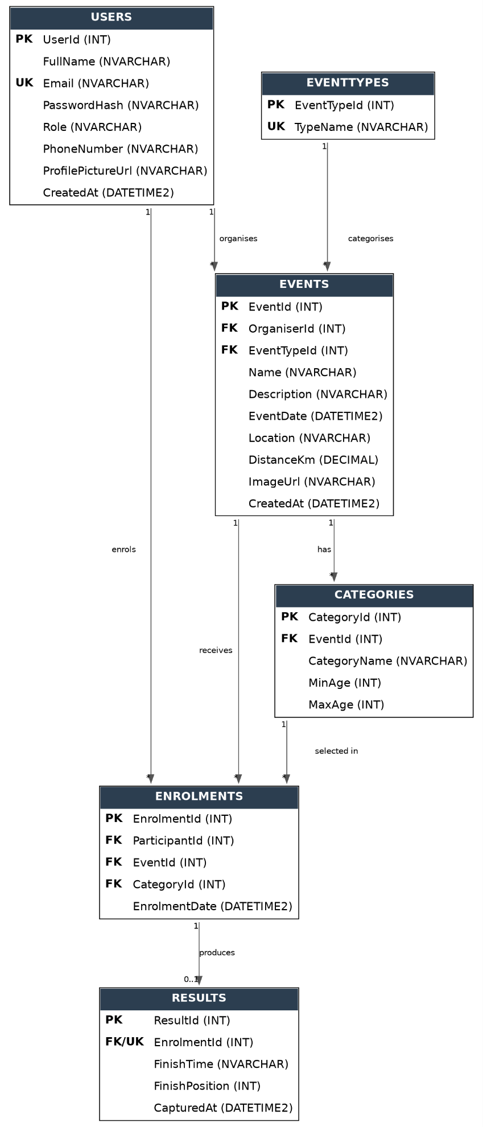

Section B – API Endpoint Plan

This table lists every API endpoint planned for the RaceDay system, covering Authentication, User Profile, Events, Categories, Event Enrolments, and Results. This plan was completed before any API code was written. The implemented API in Part 2 will closely follow this plan.

Authentication

| HTTP Method | Route | Description | Role Required | Request Body | Expected Response |
|---|---|---|---|---|---|
| POST | /api/auth/register | Creates a new user account as either an Organiser or a Participant | None | `{ fullName, email, password, role, phoneNumber }` | 201 Created – user created<br>400 Bad Request – invalid data<br>409 Conflict – email already registered |
| POST | /api/auth/login | Authenticates a user and starts a session storing their user ID and role | None | `{ email, password }` | 200 OK – session started, returns user and role<br>401 Unauthorized – invalid credentials |
| POST | /api/auth/logout | Ends the current user's session | Any | None | 200 OK – session cleared |

User Profile

| HTTP Method | Route | Description | Role Required | Request Body | Expected Response |
|---|---|---|---|---|---|
| GET | /api/users/me | Returns the logged-in user's own profile details | Any | None | 200 OK – profile data<br>401 Unauthorized |
| PUT | /api/users/me | Updates the logged-in user's own profile (name, phone, profile picture) | Any | `{ fullName, phoneNumber, profilePictureUrl }` | 200 OK – updated profile<br>400 Bad Request<br>401 Unauthorized |

Events

| HTTP Method | Route | Description | Role Required | Request Body | Expected Response |
|---|---|---|---|---|---|
| GET | /api/events | Lists all upcoming events, viewable by anyone | None | None | 200 OK – list of events |
| GET | /api/events/{id} | Returns full detail for a single event | None | None | 200 OK – event detail<br>404 Not Found |
| POST | /api/events | Creates a new event | Organiser | `{ name, description, eventDate, location, distanceKm, eventTypeId, imageUrl }` | 201 Created – event created<br>400 Bad Request<br>401 Unauthorized<br>403 Forbidden |
| PUT | /api/events/{id} | Updates an existing event owned by the Organiser | Organiser | `{ name, description, eventDate, location, distanceKm, eventTypeId, imageUrl }` | 200 OK – updated<br>400 Bad Request<br>401 Unauthorized<br>403 Forbidden – not the owner<br>404 Not Found |
| DELETE | /api/events/{id} | Deletes an event owned by the Organiser | Organiser | None | 204 No Content<br>401 Unauthorized<br>403 Forbidden<br>404 Not Found |

Categories

| HTTP Method | Route | Description | Role Required | Request Body | Expected Response |
|---|---|---|---|---|---|
| GET | /api/events/{eventId}/categories | Lists all categories available for a specific event | None | None | 200 OK – list of categories<br>404 Not Found |
| POST | /api/events/{eventId}/categories | Adds a new age or distance category to an event | Organiser | `{ categoryName, minAge, maxAge }` | 201 Created<br>400 Bad Request<br>401 Unauthorized<br>403 Forbidden<br>404 Not Found |
| PUT | /api/categories/{id} | Updates an existing category | Organiser | `{ categoryName, minAge, maxAge }` | 200 OK<br>400 Bad Request<br>401 Unauthorized<br>403 Forbidden<br>404 Not Found |
| DELETE | /api/categories/{id} | Removes a category from an event | Organiser | None | 204 No Content<br>401 Unauthorized<br>403 Forbidden<br>404 Not Found |

Event Enrolments

| HTTP Method | Route | Description | Role Required | Request Body | Expected Response |
|---|---|---|---|---|---|
| POST | /api/enrolments | Enrols the logged-in Participant into an event under a chosen category | Participant | `{ eventId, categoryId }` | 201 Created – enrolment recorded<br>400 Bad Request<br>401 Unauthorized<br>403 Forbidden<br>409 Conflict – already enrolled |
| GET | /api/enrolments/me | Returns all events the logged-in Participant has enrolled in | Participant | None | 200 OK – list of enrolments<br>401 Unauthorized |
| GET | /api/events/{eventId}/enrolments | Returns all Participants enrolled in a specific event, for the Organiser managing it | Organiser | None | 200 OK – list of enrolments<br>401 Unauthorized<br>403 Forbidden – not the event owner<br>404 Not Found |

Results

| HTTP Method | Route | Description | Role Required | Request Body | Expected Response |
|---|---|---|---|---|---|
| POST | /api/results | Captures a finish time and position for a specific enrolment after an event | Organiser | `{ enrolmentId, finishTime, finishPosition }` | 201 Created<br>400 Bad Request<br>401 Unauthorized<br>403 Forbidden – not the event owner<br>404 Not Found |
| GET | /api/results/me | Returns the logged-in Participant's own race result history | Participant | None | 200 OK – list of results<br>401 Unauthorized |

Supporting Endpoint

| HTTP Method | Route | Description | Role Required | Request Body | Expected Response |
|---|---|---|---|---|---|
| GET | /api/eventtypes | Lists available event types (Run, Walk, Cycle) for populating dropdowns | None | None | 200 OK – list of event types |

Notes on Role Enforcement

- **401 Unauthorized** is returned when no valid session exists (the user is not logged in at all).
- **403 Forbidden** is returned when a valid session exists but the user's role, or ownership of the resource, does not permit the action (for example, a Participant calling an Organiser-only endpoint, or an Organiser attempting to modify another Organiser's event).
- Categories and Enrolments are nested under `/api/events/{eventId}/...` where they logically belong to a parent event, following standard REST resource hierarchy conventions.

